Email Capture 使用者導覽

1. 點擊「系統」->「系統管理」

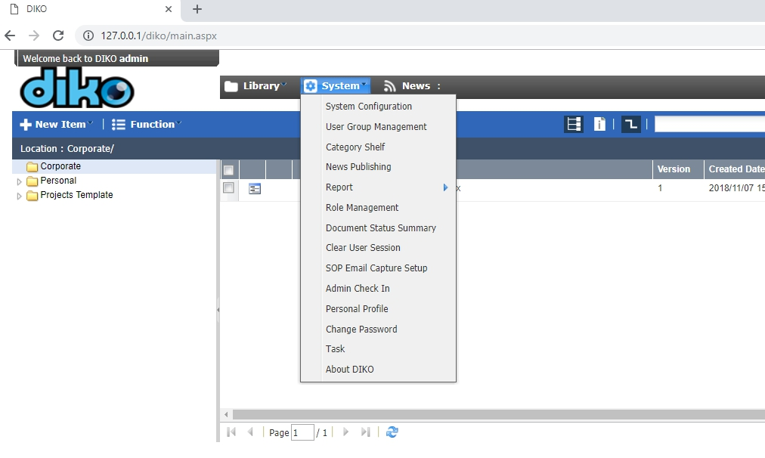

1. 在「系統管理」底下，點擊「檢視電子郵件設定」

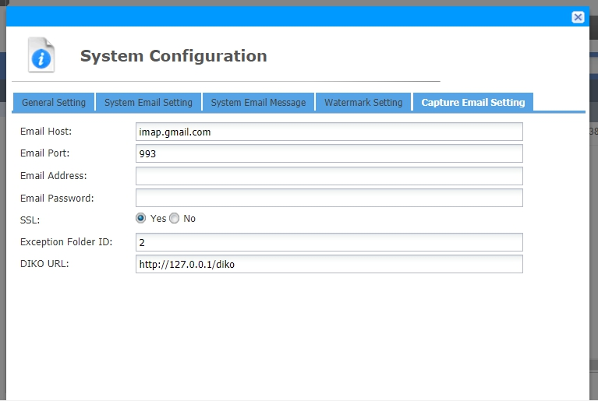

1. 輸入你的**收到電子郵件**收件箱信息

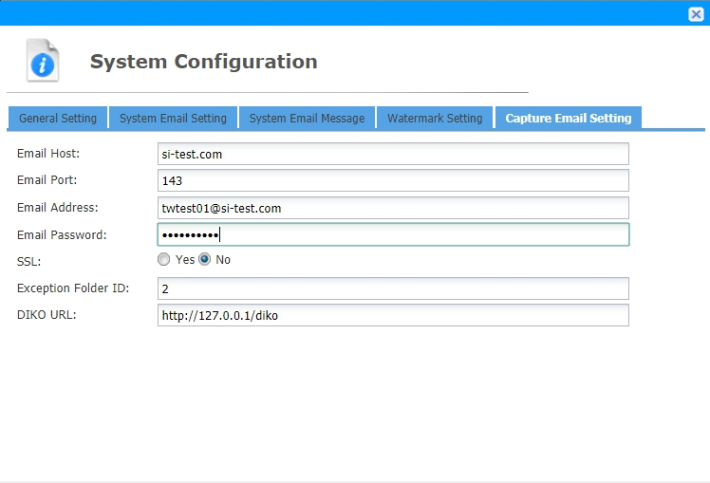

1. 向下滾動，然後按一下「保存」

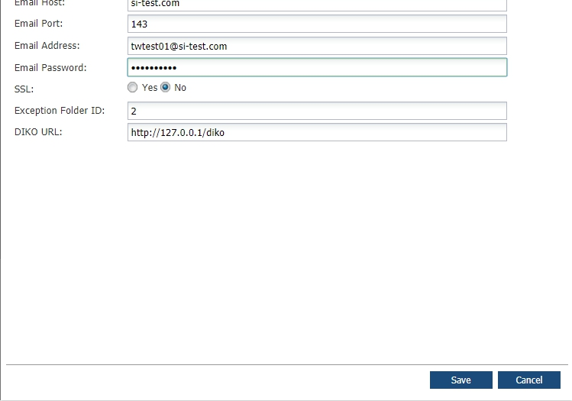

1. 點擊「系統」底下的「更改個人資料」，設置您的個人電子郵件，保存

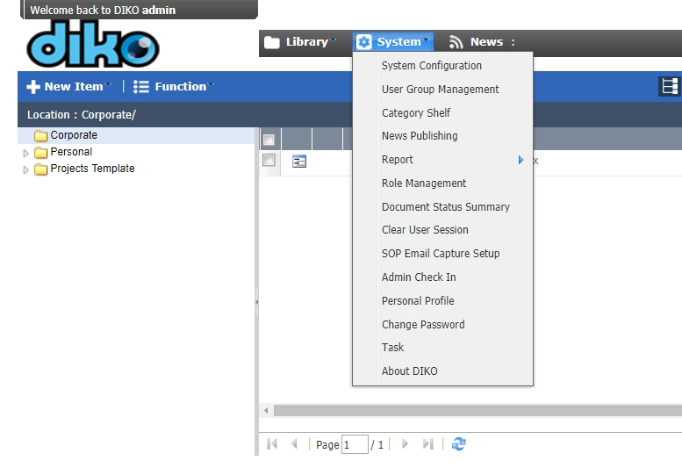

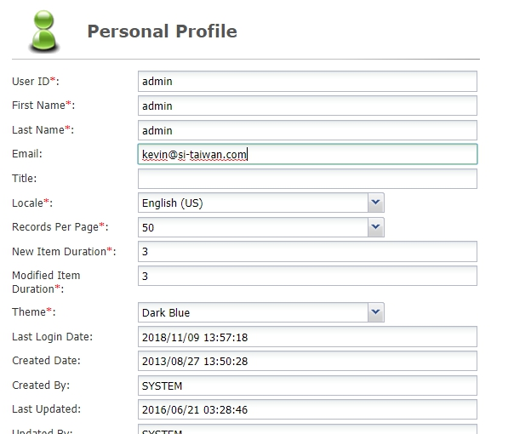

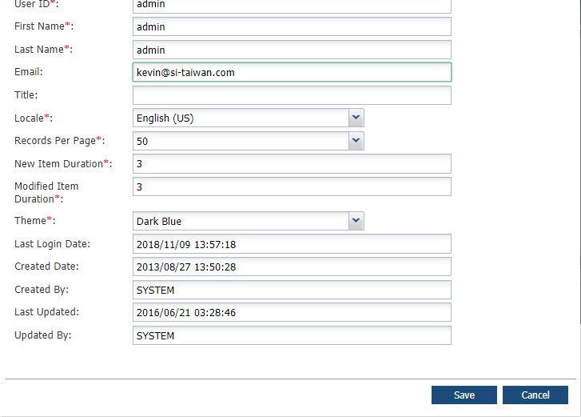

1. FROM any account’s E-mail address, send a mail to the Receiving E-mail Address to have the mail archived under your account’s Personal Folder (You can attach files and add message contents as well)

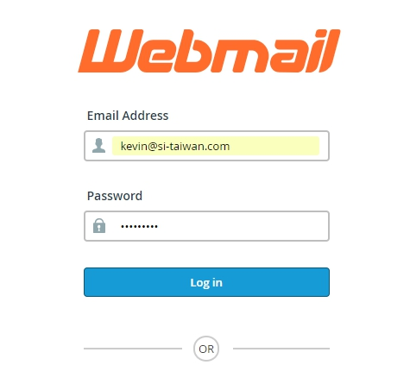

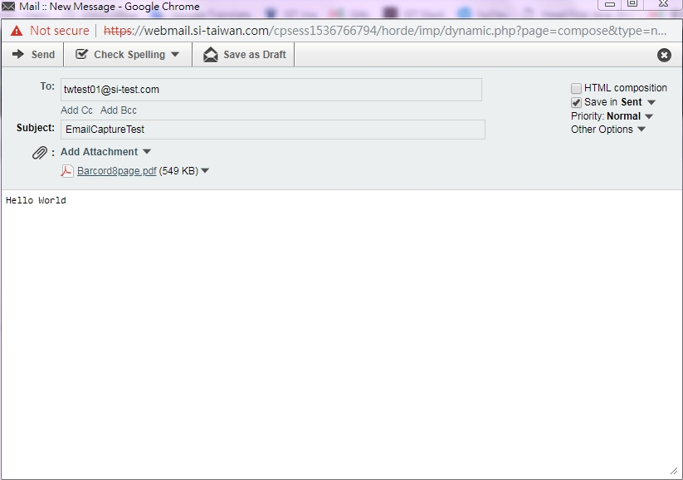

1. All mails sent from user email to receiving email([twtest01@si-test.com](mailto:twtest01@si-test.com)) will be archived under user’s Personal Folder, with the attachment, message and title all stored.

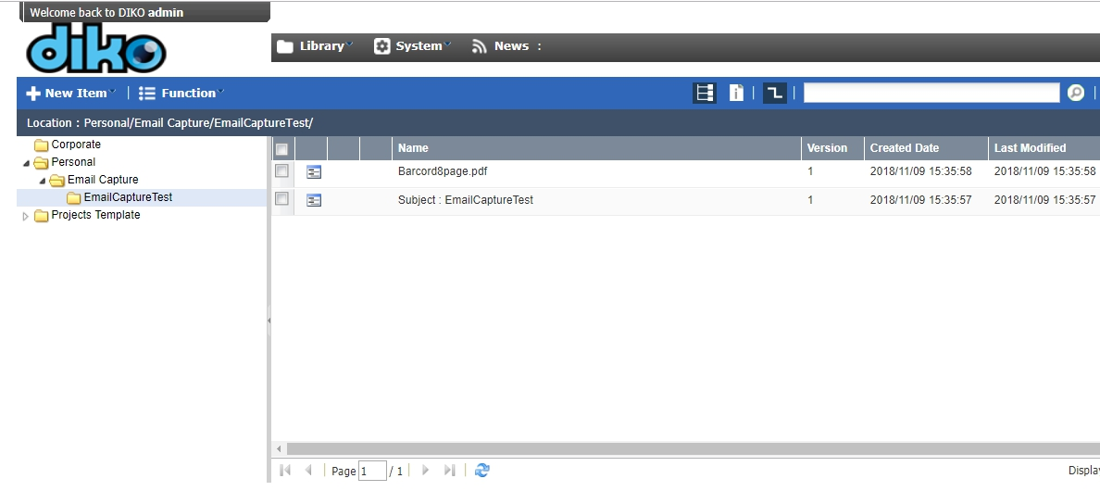

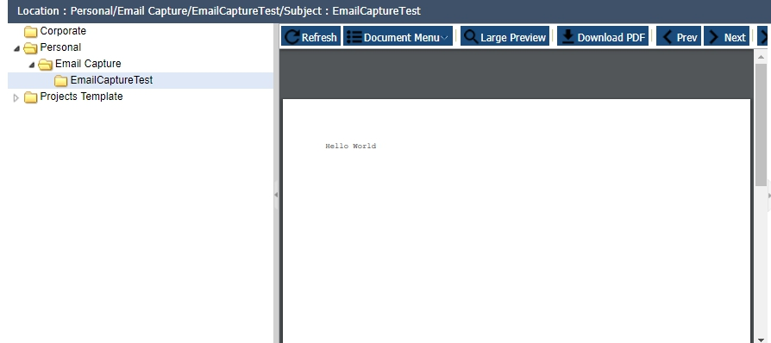

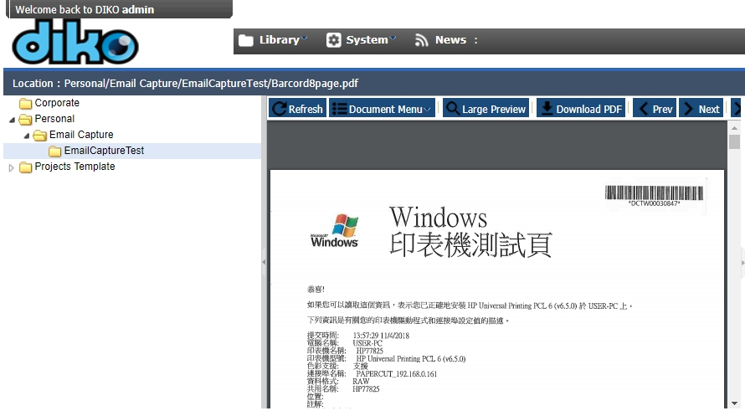

8. Note that Email Capture is designed to work well with MFP(Multi Function Printers) as users can scan from the printer and directly have the scanned documents be input and archived into DIKO's personal folder.